2019 Texas Lutheran University Basketball Elite Camp

Elite Camp

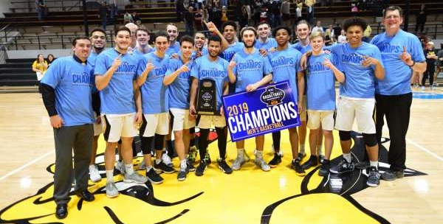

Come out and enjoy a full day of fun with our players and coaching staff. We look forward to helping you get better on the court as well as teaching you personal values that will help you succeed in life! We hope to see YOU there!!

September 14th 11 AM – 4 PM

- Camp Includes: Individual Skill Work, Competitive Drills, and 5-on-5 games
- Campers will receive instructions from the entire TLU coaching staff and current players
- Camp also includes an admissions and financial aid workshop, a campus tour, and a tailgate with the current Bulldog basketball team
- Campers and guests are invited to attend the TLU home football game @ 6 PM
- Camp is open to Sophomores, Juniors, and Seniors, Boys grades 10-12. CAMP FEE: $30
- Parking will be available on the south side of Jones Complex.
(REGISTRATION IS DUE BY SEPTEMBER 7TH!!!)

Camp Itinerary is included on the back of this page

TLU ELITE CAMP ITINERARY

10:30 – 11:00 – CHECK-IN/REGISTRATION

11:00 – 11:45 – FINANCIAL AID & ADMISSIONS PRESENTATION

11:45 – 12:45 – WARM-UP/STRETCH & FULL COURT DRILLS

12:45 – 1:45 – STATION DRILLS

1:45 – 3:45 – FULL COURT GAMES

3:45 – 4:00 – COOL DOWN & CLOSING REMARKS

4:00 – 5:00 – CAMPUS TOUR

5:00 – 6:00 TAILGATE BEFORE FOOTBALL GAME W/ FOOD AND DRINKS

6:00 – 9:00 TLU FOOTBALL GAME VS. HENDRIX

NAME: PHONE: E-MAIL:

HOME ADDRESS: CITY: STATE: ZIP:

PARENT’S NAME: PHONE: E-MAIL:

HIGH SCHOOL: GRAD YEAR:

PPG: RPG: APG: SPG: BPG:

BASKETBALL AWARDS:

ACADEMIC AWARDS:

GPA: SAT (MATH & READING): ACT:

Do plan to attend the TLU football game? ______ If Yes, Total Tickets Needed________

Contact Info/Register To: For Additional Information Please Contact:

ATTN: Men’s Basketball Head Coach Mike Wacker-(210)-573-3965 (or)
Texas Lutheran University coachwacker@gmail.com
1000 W. Court St. Associate Head Coach Austin Falke-(512)-269-6217
Seguin, Tx 78155 (or) afalke@tlu.edu
Assistant Coach Jacob Kouremetis-(210)-638-9251 (or)
jamkouremetis@tlu.edu

Health History Form located on back of this page. Please fill out the registration form along with the Health History form and send to the address above along with payment. Cash or Checks are welcome. Please make Checks out to TLU Men’s Basketball. We hope to see you on the 14th!

Emergency Contact
Name:__________________________________
Phone:__________________________________
Insurance Company:_______________________
Policy Number:____________________________
Physicians Name:__________________________
Physicians Phone:__________________________
Emergency contact if parents can’t be reached:__________________________________
Note: No camper will be permitted to leave camp unless accompanied by an authorized adult.
Health History
Allergies
Medication________________________________
Food______________________________________
Other (Insect,etc.)_________________________________
___Seizures ___Asthma
___Diabetes ___Ear Infections
___Heart Disease ___Back Problems
__ADHD __Emotional Difficulty
Other______________________________________
Recent Operations/Injuries/Illnesses_____________________________________________________________
Limitations to Activity____________________________________
First aid provider may give my child the following:
__Ibuprofen __Acetaminophen (i.e. Tylenol)
__Chloroseptic Losenges
__Diphehydramine (Antihistamine, i.e. Benadryl)
__Imodium AD __Caladryl Lotion
__Decongestant (i.e. Sudafed)

If at any time it is necessary for my child/ward, hereinafter referred to as “camper”, to receive outside or professional medical attention for an injury sustained at Texas Lutheran University’s (TLU) Camp, hereinafter referred to as “camp”, I hereby give my consent to the camp director to secure necessary services. The camp director will attempt to contact me, but the TLU athletic trainer, camp nurse, or the Guadalupe Regional Medical Center and its doctors and nurses have my permission to treat and/or prescribe medications to the camper while enrolled or participating in any activity under the auspices of TLU. Also, I do hereby for myself, my heirs, executors, and administrators release, absolve and hold harmless the camp, its employees and agents from any and all liability for any injuries, illnesses, or damage to person or property incurred while at camp, which may include but are not limited to cuts, bruises, sprains, strains, and broken bones.
In accordance with the rules of TLU’s camp, I, the undersigned parent and/or legal guardian, hereby give my consent for my child/ward to participate in all camp activities except:__________________________________________________________________________________________
____________________________ _____________
Parent/Guardian Signature Date

GO BULLDOGS!

